**Investigating Inclined Planes**

**Aim:** To measure the force required to lift a load vertically and to lift it using ramps of differing slope.

**Equipment:** Trolley

Spring balances

Books or bricks

Wooden ramp

Protractor

**Method:**

1. Position a plank of wood on a pile of books (or a brick and some books) to make a ramp that is about 10 cm high.
2. Attach the trolley to a spring balance. Carefully lift it vertically until its rear is level with the height of your ramp. Record this weight as the load force.
3. Measure the angle of elevation of the ramp and its distance from the base to the pile of books. Record these values in the table.
4. Slowly drag the trolley up the ramp to the pile of books. Record the effort force required.
5. Repeat steps 3 and 4 for four different angles of the ramp. Measure the new ramp length and effort force each time.

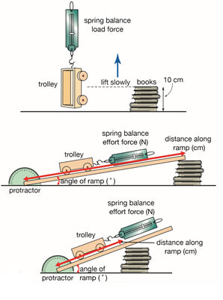

**Results:**

|  |  |  |  |  |  |  |  |
| --- | --- | --- | --- | --- | --- | --- | --- |
| Load Force (N) | Angle of Ramp (°) | Ramp Length (cm) | Effort 1 (N) | Effort 2 (N) | Effort 3 (N) | Average Effort (N) | Mechanical Advantage |
|  |  |  |  |  |  |  |  |
|  |  |  |  |  |  |  |  |
|  |  |  |  |  |  |  |  |
|  |  |  |  |  |  |  |  |

**Questions:**

1. Calculate the mechanical advantage of each ramp using the formula below and record it in the table.
$$mechanical advantage= \frac{load}{effort}$$

2. State the:
   1. Independent Variable
   2. Dependent Variable
   3. Control Variables
3. Draw a graph of the ramp length vs. mechanical advantage.
4. Describe any pattern you can see in the data you have collected.
5. State whether having a large or a smaller angle of ramp increased its mechanical advantage.
6. Explain why this occurred, considering how the effective distance of the ramp varied with the changing angle.
7. List three situations in which using a ramp at a shopping centre is useful.

**Results:**

|  |  |  |  |  |  |  |  |
| --- | --- | --- | --- | --- | --- | --- | --- |
| Load Force (N) | Angle of Ramp (°) | Ramp Length (cm) | Effort 1 (N) | Effort 2 (N) | Effort 3 (N) | Average Effort (N) | Mechanical Advantage |
| 3.5 | 5 | 60 |  |  |  | 0.5 | 7 |
| 3.5 | 15 | 53 |  |  |  | 1.1 | 3.2 |
| 3.5 | 20 | 47 |  |  |  | 1.5 | 2.3 |
| 3.5 | 30 | 38 |  |  |  | 2.3 | 1.5 |